function y=caida(t,m,c,g)

%syms t

y=(g\*m/c)\*(1-exp(-c\*t/m));

end

%m=input('ingrese Masa del cuerpo : ');

%c=input('ingrese Coeficiente de Arrastre: ');

%g=input('gravedad [g] : ');

function [r,h]=trapeq(f,a,b,n)

h=(b-a)/n;

x=a;

s=f(x);

for i=1:n

x=x+h;

s=s+2\*f(x);

end

s=s+f(b);

r=0.5\*h\*s;

end

----------------------------------------------------------------------------------------------------------------------

function p=simpson3(f,a,b,n)

h=(b-a)/n;

n=n+1;

y=zeros(n,1);

x=zeros(n,1);

suma=0;

for i=1:n

x(i)=a+h\*(i-1);

y(i)=f(x(i));

end

for i=2:n-1

if rem(i,2)==1

suma=suma+2\*y(i);

else

suma=suma+4\*y(i);

end

end

p=h\*(y(1)+suma+y(n))/3;

end

function p=simpson8(f,a,b,n)

h=(b-a)/n;

n=n+1;

y=zeros(n,1);

x=zeros(n,1);

suma=0;

for i=1:n

x(i)=a+h\*(i-1);

y(i)=f(x(i));

end

for i=2:n-1

if rem(i-1,3)==0

suma=suma+2\*y(i);

else

suma=suma+3\*y(i);

end

end

p=3\*h\*(y(1)+suma+y(n))/8;

end

PROGRAMA PRINCIPAL

%programa principal

clear all

close all

clc

%ti=input('INGRESE TIEMPO [t] : ');

%es=input('INGRESE ERROR FIJADO [es] : ');

%d=input('INGRESE VALOR VERDADERO [d]: ');

m=68.1;

c=12.5;

g=9.8;

ti=10;

es=0.0012;

d=289.43515;

i=1;

%et=2\*es;

fprintf('\nSEGMENTOS TAMANAÑO SEGMENTO d[aprox.] et[o/o]\n');

%syms t

while 1

[dist1,h]=trapeq(@(t)caida(t,m,c,g),0,ti/3,i);

dist2=simpson3(@(t)caida(t,m,c,g),ti/3,2\*ti/3,i);

dist3=simpson8(@(t)caida(t,m,c,g),2\*ti/3,ti,i);

dist=dist1+dist2+dist3;

%j=j+1;

et=100\*abs((d-dist)/d);

l=3\*i;

fprintf('%6.i %20.6f %18.6f %15.6f\n',l,h,dist,et);

i=i+1;

if et<es

break

end

end

COMPILACION:

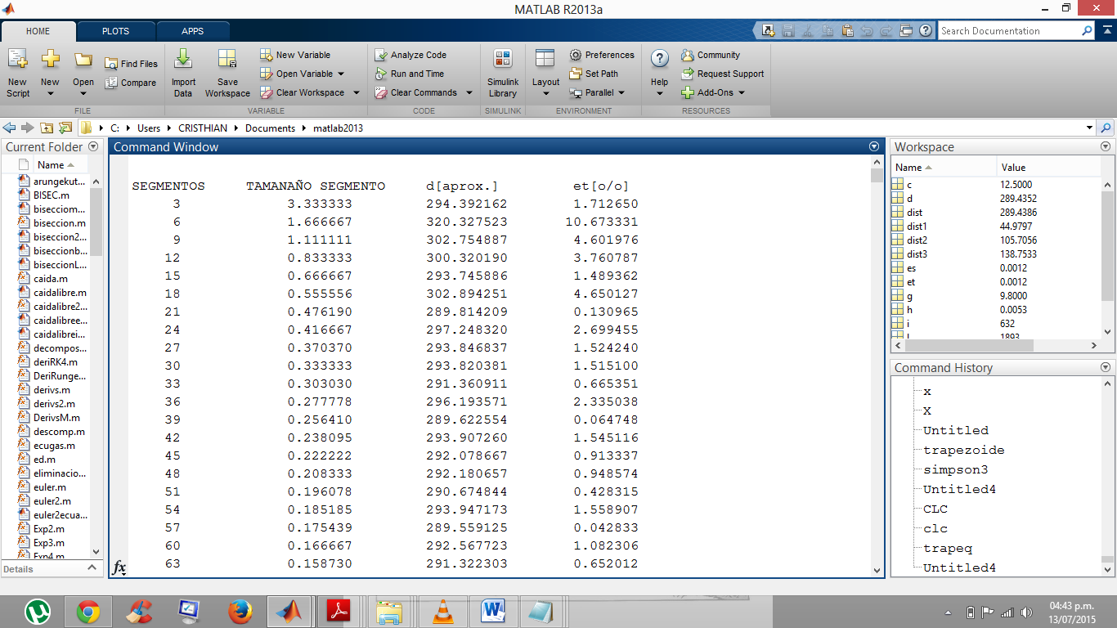

Y LO ULTIMO:

